<!DOCTYPE html>

<html>

<head>

<title>HTML List</title>

<style>

body {

display: flex;

justify-content: center;

align-items: center;

height: 40vh;

}

.table-container {

width: 80%;

}

table {

border-collapse: separate;

border-spacing: 0;

width: 80%;

border: 1px solid black;

}

th, td {

text-align: center;

padding: 10px;

border: 1px solid black;

}

th:last-child, td:last-child {

border-right: none;

}

</style>

</head>

<body>

<table>

<thead>

<tr>

<th>Team</th>

<th>City</th>

<th>Home Ground</th>

<th>Debut</th>

<th>Owner</th>

</tr>

</thead>

<tbody>

<tr>

<td>Chennai Super Kings</td>

<td>Chennai, Tamilnadu</td>

<td>M.A.Chidambaram Stadium</td>

<td>2008</td>

<td>N. Srinivasan</td>

</tr>

<tr>

<td>Delhi Capitals</td>

<td>New Delhi, Delhi</td>

<td>Arun Jaitley Stadium</td>

<td>-</td>

<td>Sajjan Jindal, G.M.Rao</td>

</tr>

<tr>

<td>Gujarat Titans</td>

<td>Ahmedabad, Gujarat</td>

<td>Narendra Modi Stadium</td>

<td>2022</td>

<td>Steve Koltes, Juhi Chawla, Jay Mehta</td>

</tr>

<tr>

<td>Kolkata Knight Riders</td>

<td>Kolkata, West Bengal</td>

<td>Eden Gardens</td>

<td>2008</td>

<td>Shah Rukh Khan, Juhi Chawla, Jay Mehta</td>

</tr>

<tr>

<td>Lucknow Super Giants</td>

<td>Lucknow, Uttar Pradesh</td>

<td>BRSABV Ekana Cricket Stadium</td>

<td>2022</td>

<td>Sanjiv Goenka</td>

</tr>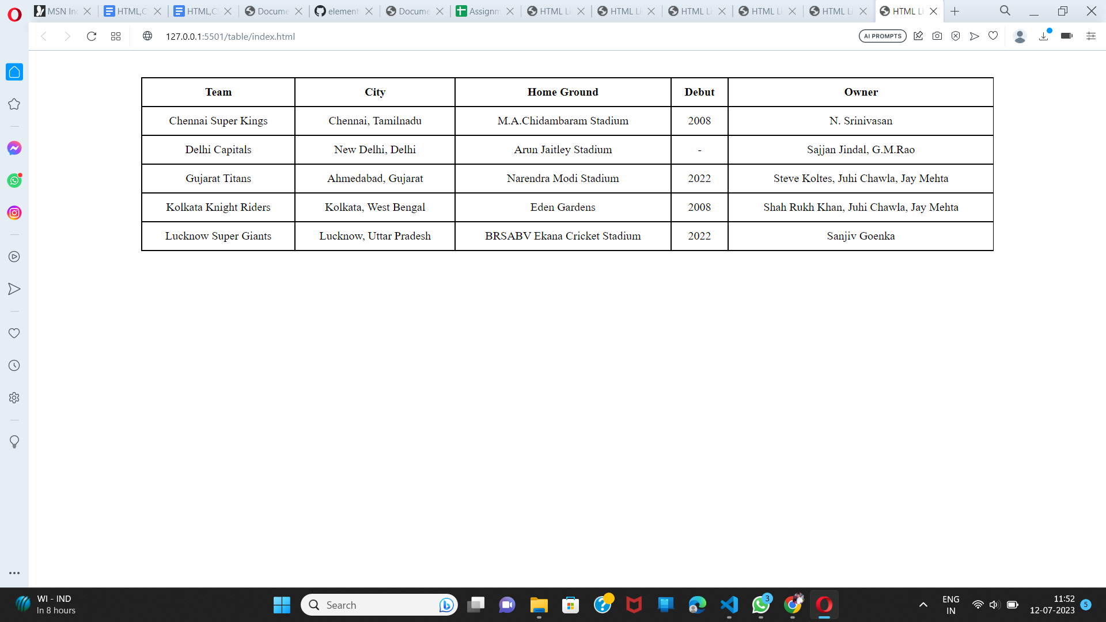

</tbody>

</table>

</body>

</html>